“An Aggie does not lie cheat or steal nor tolerate those who do”

X____________________________________________________

1.

5.1.3

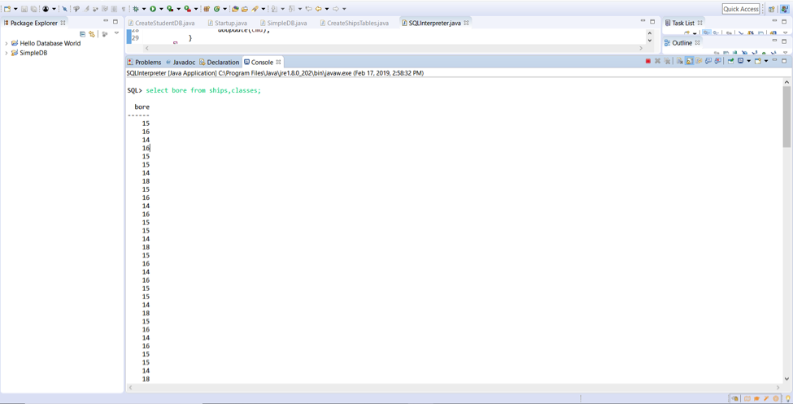

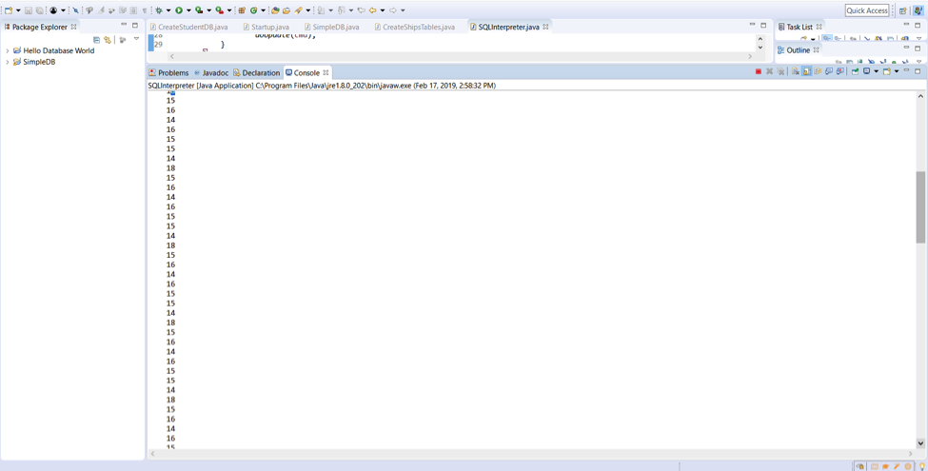

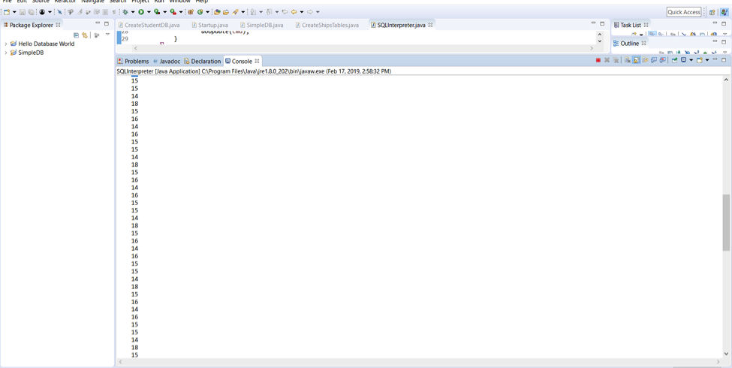

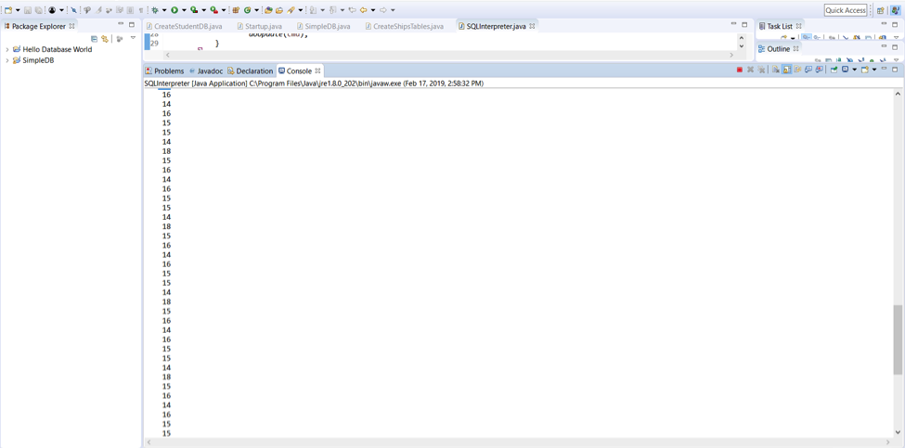

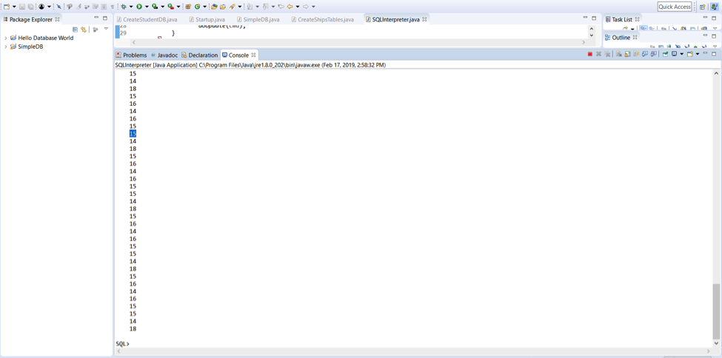

2.

5.2.1

d) τB,C(S) = [(0,1), (0,2), (2,4), (2,5), (3,4), (3,4)]

g) ϒA,SUM(B)(R)

|  |  |
| --- | --- |
| A | B |
| 0 | 1 |
| 0 | 1 |
| 2 | 3 |
| 2 | 4 |
| 3 | 4 |

|  |  |
| --- | --- |
| A | SUM(B) |
| 0 | 2 |
| 2 | 7 |
| 3 | 4 |

3.

6.1.3

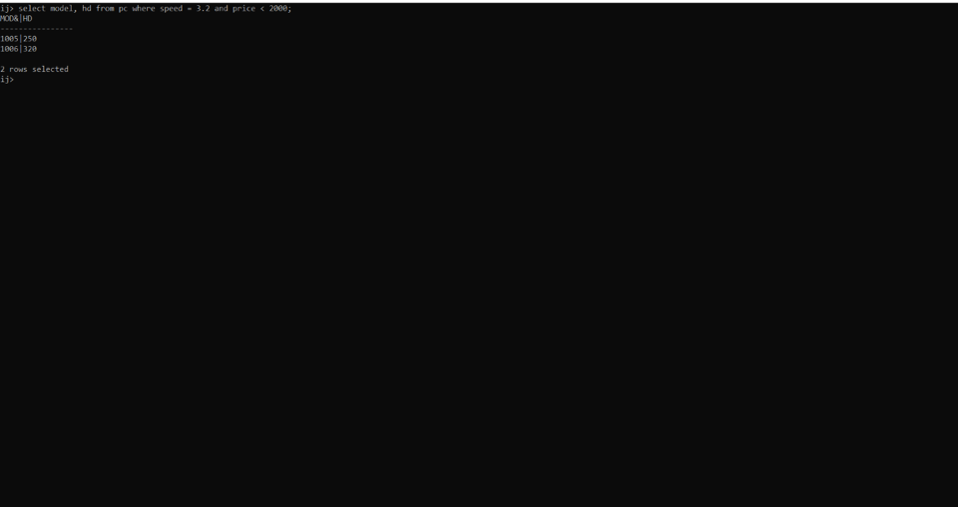

4.

6.1.4

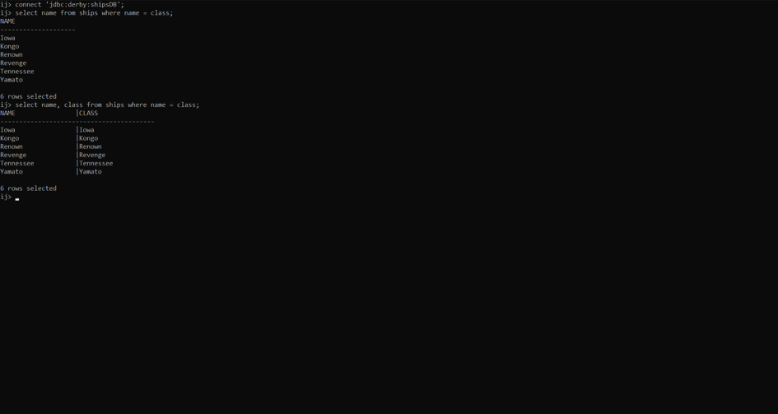

5.

6.2.2

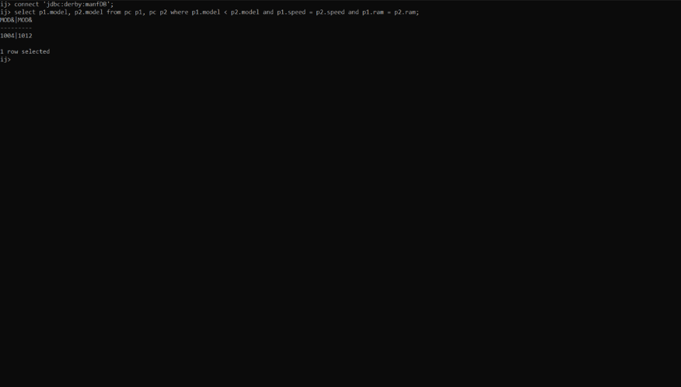

6.

6.2.3

b.

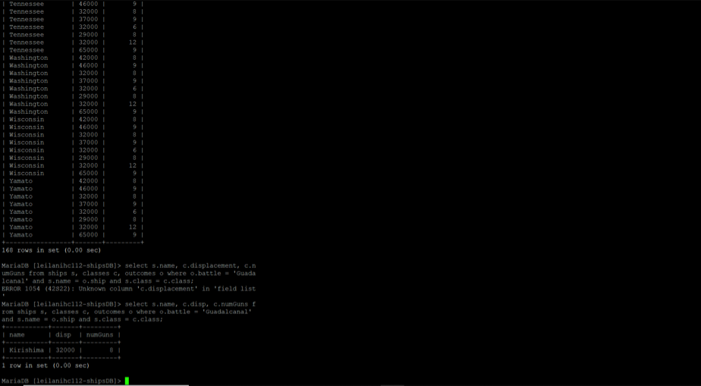

C.

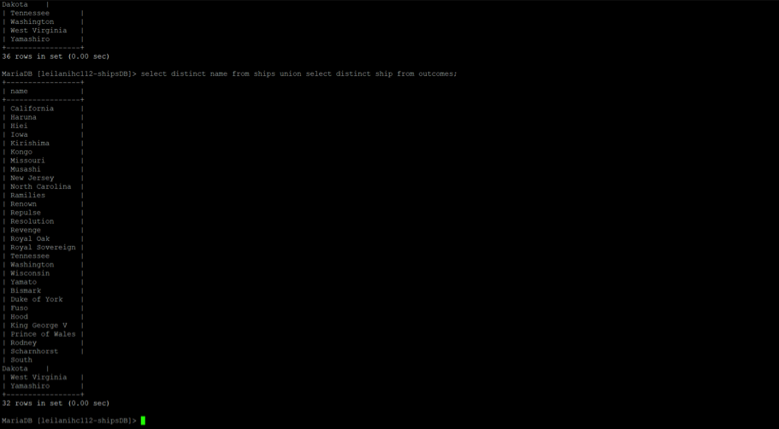

7.

6.3.1

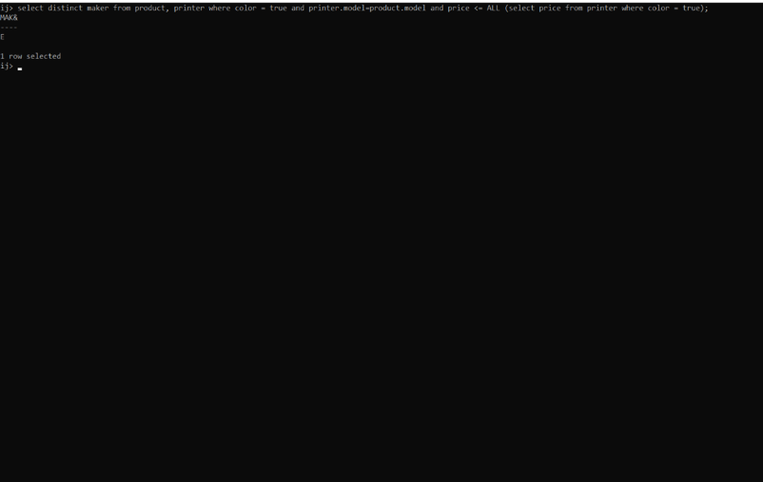

8.

6.3.2

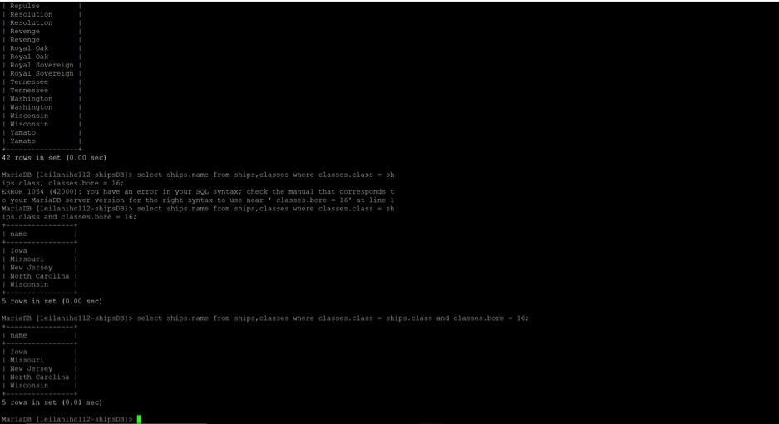

9.

6.4.6

A.

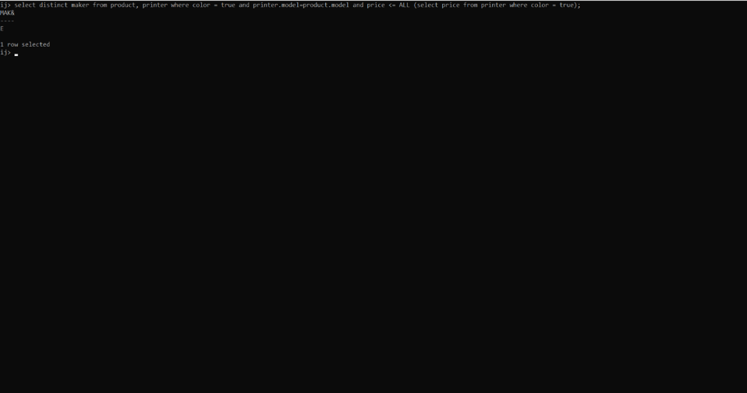

D.

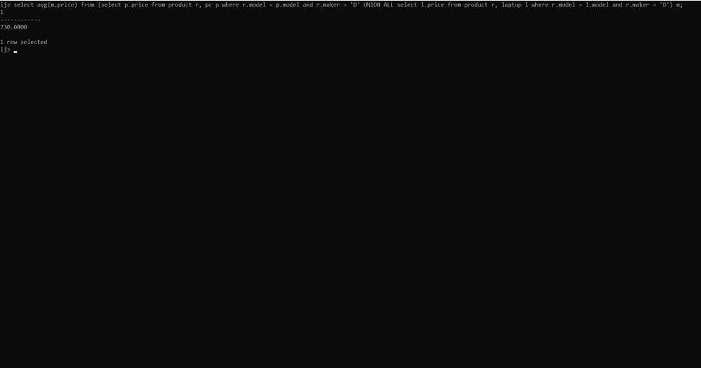

10.

6.4.7

A.

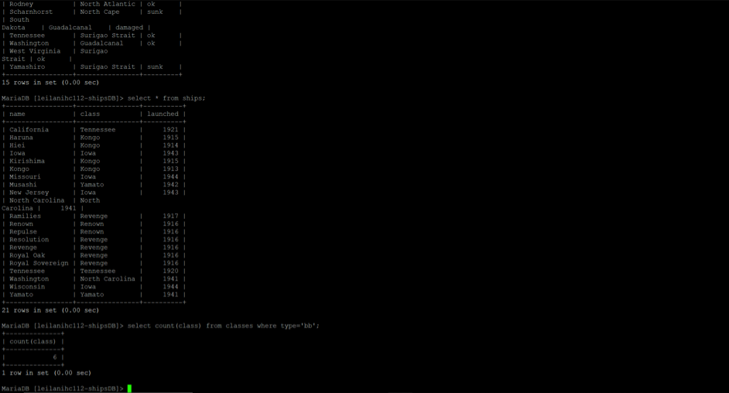

D.

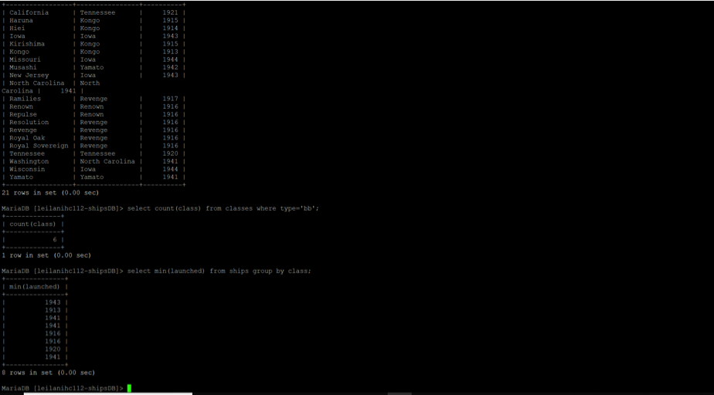

11.

Create Table Statements

* Site_Members
  + CREATE TABLE Site_Member (Email_Address VARCHAR(255), Validated TINYINT(1), Password VARCHAR(255), Secret_Question_ID INTEGER, Secret_Question_Answer VARCHAR(255), Name VARCHAR(255), Site_Member_ID INTEGER PRIMARY KEY, FOREIGN KEY (Secret_Question_ID) REFERENCES Secret_Question(Secret_Question_ID));
* Secret_Question
  + CREATE TABLE Secret_Question (Secret_Question_ID INTEGER PRIMARY KEY, Secret_Question_Text VARCHAR(255));
* Guest_List
  + CREATE TABLE Guest_List (Site_Member_ID INTEGER, Email_Address VARCHAR(255), Game_Name VARCHAR(255) PRIMARY KEY);
* Game
  + CREATE TABLE Game (Team_1 VARCHAR(255), Team_2 VARCHAR(255), Game_Members_ID INTEGER, Admin_ID INTEGER, Team_1_Score INTEGER, Team_2_Score INTEGER, Team_Won VARCHAR(255), Game_State VARCHAR(255), Game_ID INTEGER PRIMARY KEY, Game_Name VARCHAR(255), FOREIGN KEY (Game_Name) REFERENCES Guest_List(Game_Name));
* Game_Members
  + CREATE TABLE Game_Members (Game_Member_ID INTEGER PRIMARY KEY, FOREIGN KEY (Game_Member_ID) REFERENCES Site_Member(Site_Member_ID), Win_Team_Guess VARCHAR(255), Game_Total_Guess INTEGER, Guess_ID INTEGER, FOREIGN KEY (Guess_ID) REFERENCES Guesses(Guess_ID), Score INTEGER, Game_Name VARCHAR(255), FOREIGN KEY (Game_Name) REFERENCES Guest_List(Game_Name), Game_ID INTEGER, FOREIGN KEY (Game_ID) REFERENCES Game(Game_ID));
* Guesses
  + CREATE TABLE Guesses (Guess_ID INTEGER PRIMARY KEY, Game_Member_ID INTEGER, Team_Guess VARCHAR(255), Team_Guess_Correct TINYINT(1), Score_Guess INTEGER, Score_Guess_Correct TINYINT(1));

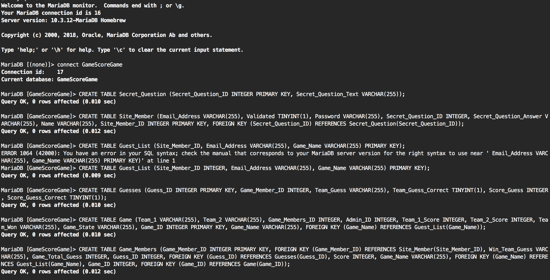

12.

